**DAILY ONLINE ACTIVITIES SUMMARY**

|  |  |  |  |  |  |  |  |  |
| --- | --- | --- | --- | --- | --- | --- | --- | --- |
| **Date:** | **31/05/2020** | | | | | **Name:** | **Albin Francis** | |
| **Sem & Sec** | **8th sem,A** | | | | | **USN:** | **4AL16CS008** | |
| **Online Test Summary** | | | | | | | | |
| **Subject** | | **IOT** | | | | | | |
| **Max. Marks** | | **20** | | **Score** | | | **18** | |
| **Certification Course Summary** | | | | | | | | |
| **Course** | **PYTHON FOR DATA SCIENCE** | | | | | | | |
| **Certificate Provider** | | | **Cognitive class.ai** | | **Duration** | | | **5hr** |
| **Coding Challenges** | | | | | | | | |
| **Problem Statement:** **Write a c program to sort an array of integers in ascending order or descending order and display the sorted array and number of passes performed for sorting** | | | | | | | | |
| **Status: Solved** | | | | | | | | |
| **Uploaded the report in Github** | | | | | **Yes** | | | |
| **If yes Repository name** | | | | | **albinfrancis008** | | | |
| **Uploaded the report in slack** | | | | | **Yes** | | | |

Online Test Details: (Attach the snapshot and briefly write the report for the same)

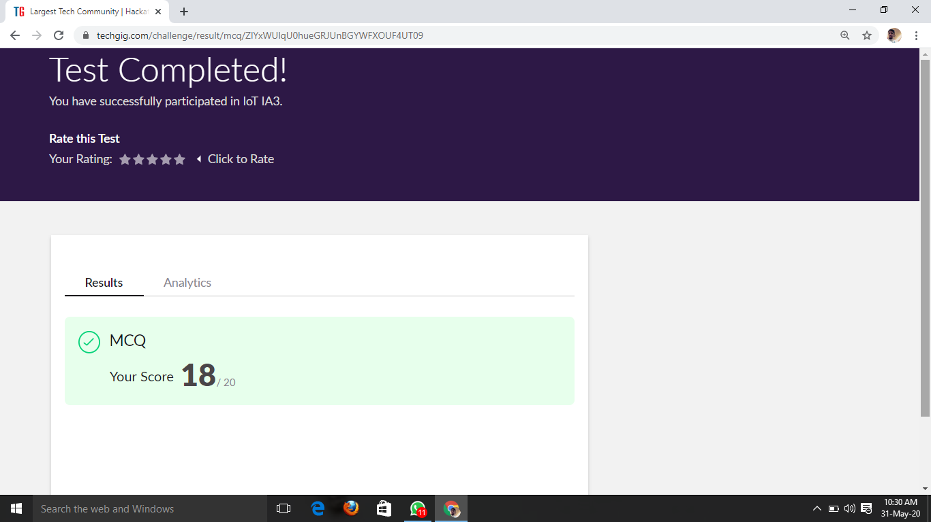

Certification Course Details: (Attach the snapshot and briefly write the report for the same)

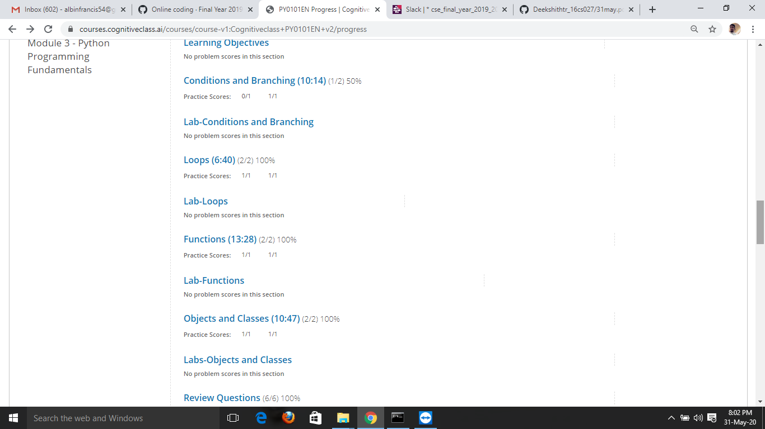

Coding Challenges Details: (Attach the snapshot and briefly write the report for the same)

**PROGRAM 1**

/* Write a c program to sort an array of integers in ascending order or descending order

and display the sorted array and number of passes performed for sorting. */

#includestdio.h

voidswap(int*xp,int*yp)

{

inttemp=*xp;

*xp=*yp;

*yp=temp;

}

intbubbleSort(intarr[],intn)

{

inti,j,count=0;

intswapped;

for(i=0;i<n-1;i++)

{

swapped=0;

for(j=0;j<n-i-1;j++)

{

if(arr[j]>arr[j+1])

{

swap(&arr[j],&arr[j+1]);

swapped=1;

count++;

}

}

if(swapped==0)

break;

}

returncount;

}

voidprintArray(intarr[],intsize)

{

inti;

for(i=0;i<size;i++)

printf("%d",arr[i])

printf("\n");

}

intmain()

{

intarr[50],num;

printf("enterthenumberofelements");

scanf("%d",&num);

printf("entertheelements");

for(inti=0;i=n;i++)

}